Homework Assignment 3
BAN 620 - DATA MINING

Group 2
Khush Domadiya – fr9739
Chenghui Tan – sw5299
Mohanasundaram Murugesan – vw4192
Amisha Farhana Shaik – ac1425

- Universal Bank dataset

We have a Universal Bank Dataset which contains columns as below:
Using this dataset, we are going classify a new data point into ‘Personal Loan’ or not.

- k-NN classification with k=3
The below is the new data point we are going to classify.

After performing the KNN classification with K as 3, the below is the output. Which states that our new data point has been classified into 0, which means that the individual does not have a ‘Personal Loan’

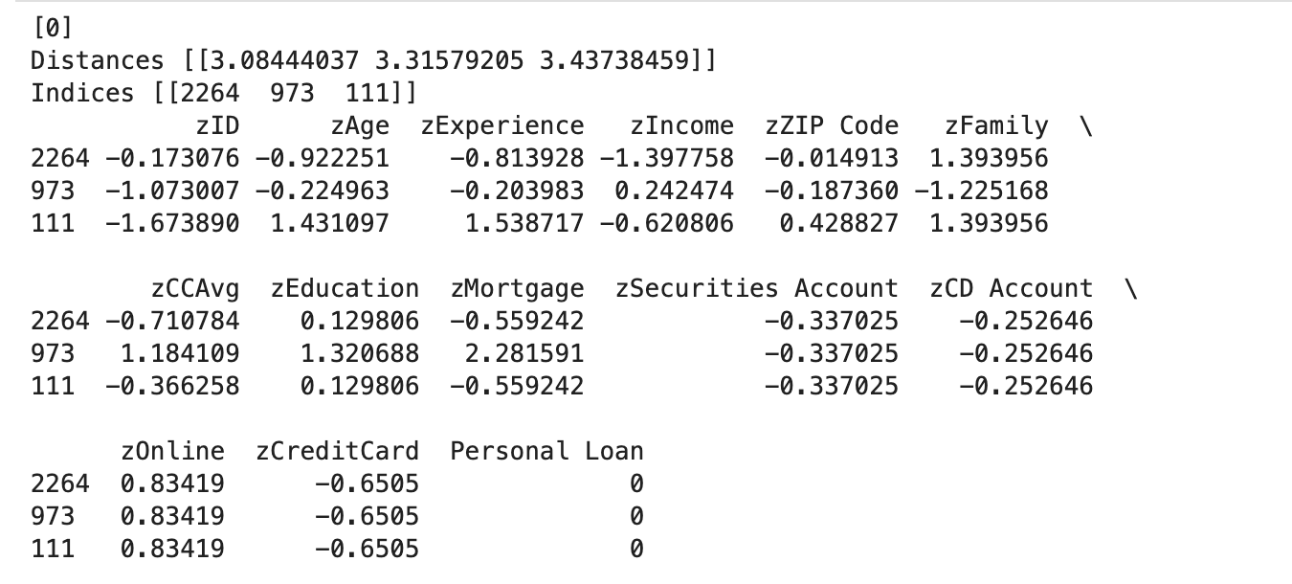

- Best K:
The below is the accuracy for different K’s. We observe that accuracy increases until K = 7, after which the accuracy decreases when K increases. Therefore, K = 7 is the best K as it has the best accuracy.

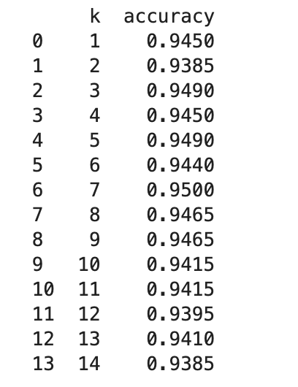
- Classification Tree

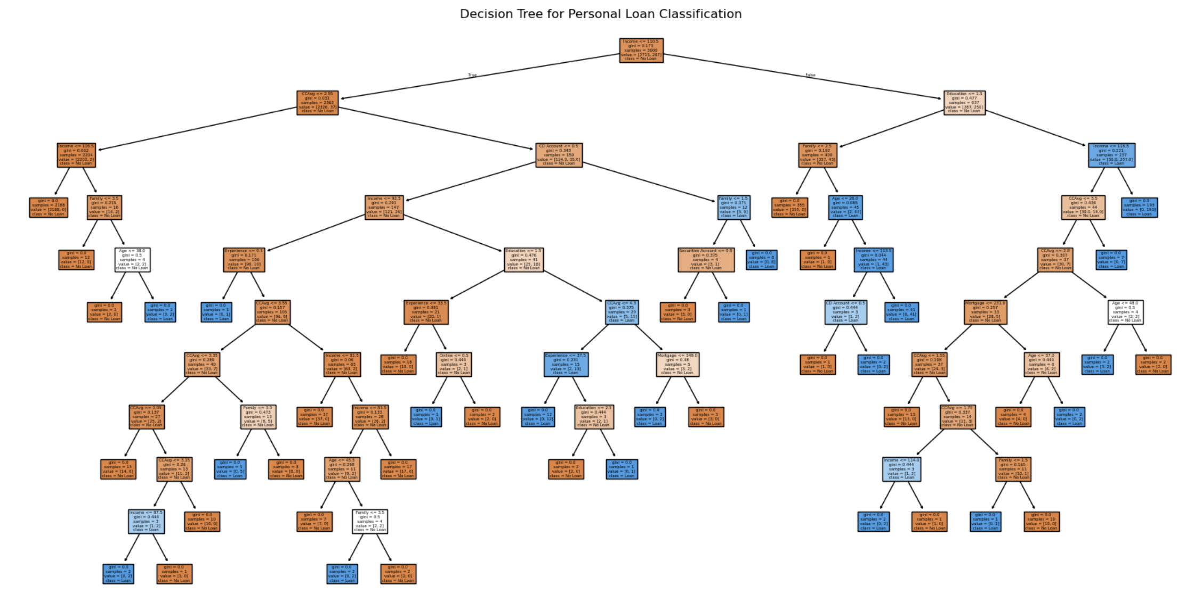
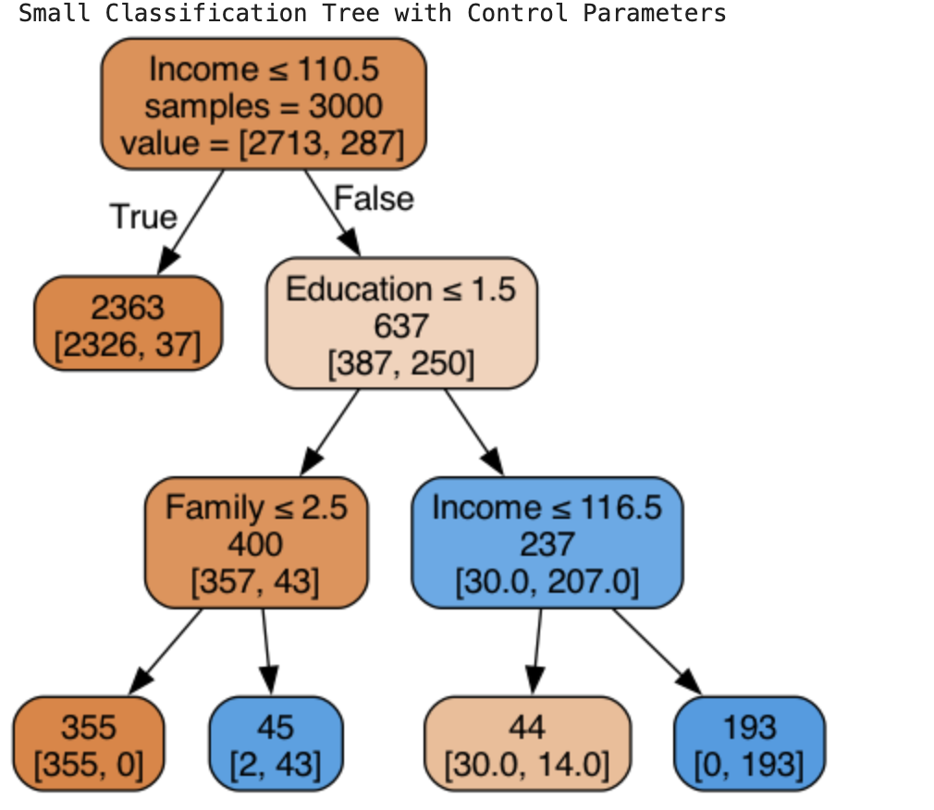

- KNN or Tree

Because the best k in KNN is 7, and its accuracy of the performance on validation data set is 0.9500. Through 5-fold cross validation, the accuracy is 0.954.

For classification tree, its accuracy of the performance on validation data set is 0.9800 Through 5-fold cross validation, the accuracy is 0.986.

In both the cases, classification tree has higher accuracy, therefore we choose the tree.

- eBayAuctions dataset

- Decision Tree

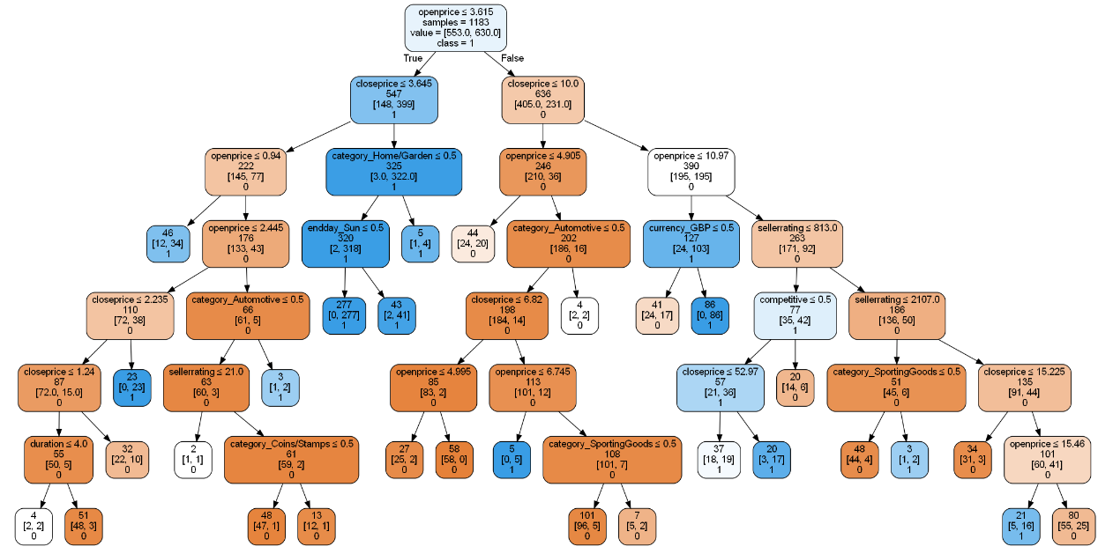

Rule:
- If the openprice is less than or equal to 3.615 and closing price is greater than 3.645 then it is likely to be competitive.
- If the openprice is greater than 3.615 and the closeprice is less than or equal to 10.0, then it is most likely to be non-competitive (except for just 5 samples from the entire dataset

- Decision Tree
The above decision tree included all the variables even “closeprice”, which is only known after the auction has started or ended. Variables like these make the model less useful for predicting new auctions, as we wouldn't have access to them in advance. Therefore, to improve predictive accuracy for a new auction, we should exclude closeprice and build the tree using only pre-listing information such as 'category', 'currency', 'sellerrating', 'duration', 'endday', and 'openprice'.
The below tree would help sellers predict auction competitiveness based solely on variables they can set or know at the start.

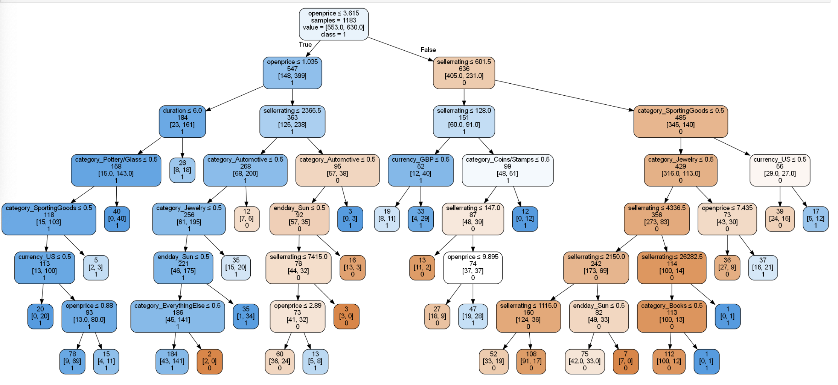

2c.Recommendations:

- Set the Opening Price Below $1.035: If you look at the left side of the decision tree especially after the opening price is below 1.035 all the branches lead to competitiveness regardless of the category or duration. Hence auctions with an opening price below this threshold will have higher competitiveness.
- List Auctions to End on Days Other Than Sunday: According to the decision tree, auctions that end on days other than Sunday tend to be more competitive. In multiple branches of the tree, when endday_Sun ≤ 0.5 is true, higher competitiveness can be observed.
- Use Auction Durations of 6 Days or Less for Higher Competitiveness. According to the decision tree, auctions with a duration of 6 days or fewer are often associated with more competitive outcomes. The first split in the tree shows that when duration ≤ 6.0, the likelihood of a competitive auction increases.

3.DRISHYA AI LAB CASE:

Existing problem: Osum Oil Sands Corp. is experiencing frequent alarm floods and chattering at their SAGD plant, leading to potential downtime and production losses

Goal: The primary goal is to enhance alarm intelligence to improve operator performance and reduce plant downtime.

Focus: The initial focus will be on the evaporator system (3K-tag series) as it is a critical system in the plant

Analysis of Alarm Tag Identifier:
Knn:
- K=3
  - The accuracy score on validation dataset when k=3 is 0.8895
- The best k for the given dataset is 6. Thus, when k=6
  - The accuracy score on validation dataset when k=6 is 0.897375
  - The accuracy score on test dataset when k=6 is 0.7935
Decision Tree:
- Train data:
  - Accuracy: 96.37%
  - True Negatives (TN): 9121 (No chattering alarm correctly predicted as no)
  - False Positives (FP): 161 (No chattering alarm incorrectly predicted as yes)
  - False Negatives (FN): 275 (Chattering alarm incorrectly predicted as no)
  - True Positives (TP): 2443 (Chattering alarm correctly predicted as yes)
- Validation data:
  - Accuracy: 87.90%
  - True Negatives (TN): 5670
  - False Positives (FP): 482
  - False Negatives (FN): 486
  - True Positives (TP): 1362
- Test data:
  - Accuracy: 81.55%
  - True Negatives (TN): 1242
  - False Positives (FP): 273
  - False Negatives (FN): 96
  - True Positives (TP): 389

- Analysis:
  - The model performs excellently on the training set (96.37% accuracy) but shows a significant drop in performance on the validation (87.90%) and test (81.55%). While it predicts "no alarm" well, it struggles with predicting "chattering alarm," leading to higher false positives and false negatives in the validation and test data
  - Higher false negatives are more costly and risky i.e. a critical alarm going unnoticed amidst the chattering could lead to equipment damage, safety hazards, or even a complete plant shutdown. This would leave operators unprepared for the ensuing alarm flood, leading to distractions, delayed responses, and potentially missed opportunities to prevent disruptions. Therefore, it is more critical to minimize false negatives (missed alarms), even at the cost of allowing some false positives (unnecessary alarms).
  - The model shows a higher tendency to miss actual chattering alarms, with False Negative Rate (FNR ) increasing from 10.1% in training to 26.3% in validation and 19.8% in test data, particularly struggling with alarm detection when applied to new data.
Most Common Alarm Tag Identifiers: PAH-3200, AAHH-3032, TAL-3730A, AAH-3032, LAL-3052, FALL-3452A, XASS-3140, FAL-3452A, LAL-3385, PDAH-3190, TAH-3038, LAH-3052, LDAH-3503, FAL-3030, LAL-3271, LAL-3171, FAL-3480, TAH-3371, TAH-3471

Analysis of chattering behaviour:
To evaluate the extent of chattering behaviour (frequent and repetitive triggering of alarms), then analysed the chb column, where chb = 1 indicates instances of chattering alarms.
Then calculated the percentage of chattering alarms for each alarm tag, measuring how often a given alarm exhibited chattering behaviour relative to its total occurrences.
ranked the alarm tags based on the absolute number of chattering alarms (chb = 1) to prioritize tags most prone to chattering. This helps in identifying the most problematic alarms that may require investigation or mitigation
The alarm tags are sorted based on the chb_1_percentage, making it easier to identify which tags have the highest percentage of chattering alarms, starting from those just above 55% up to 100%
